Ques-1:

Googe colab : <https://colab.research.google.com/drive/1ZoFMpRGGgjQz932RxSkCA7aEzoyjrI02?usp=sharing>

Ques-2:

Types of regression:

Linear Regression:

One of the most basic types of regression in machine learning, linear regression comprises a predictor variable and a dependent variable related to each other in a linear fashion. Linear regression involves the use of a best fit line.

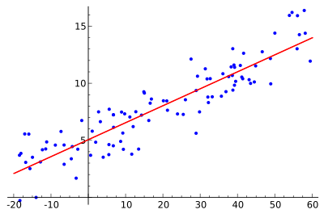

Logistic Regression:

Logistic regression uses a sigmoid curve to show the relationship between the target and independent variables. Logistic regression, also known as logit regression or logit model, is a mathematical model used in statistics to estimate (guess) the probability of an event occurring having been given some previous data. Logistic regression works with binary data, where either the event happens (1) or the event does not happen (0).

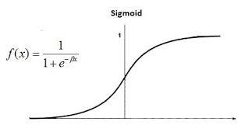

Polynomial regression:

polynomial regression is a form of regression analysis in which the relationship between the independent variable x and the dependent variable y is modelled as an nth degree polynomial in x.

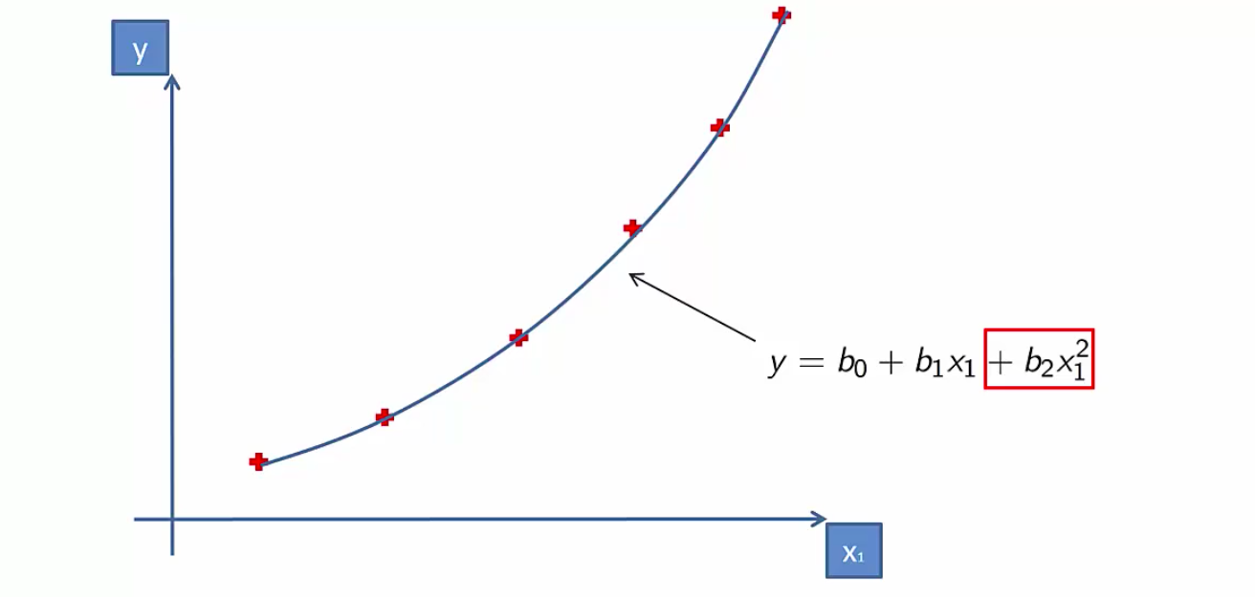

Decision tree regression:

Decision tree builds regression or classification models in the form of a tree structure. It breaks down a dataset into smaller and smaller subsets while at the same time an associated decision tree is incrementally developed. The final result is a tree with decision nodes and leaf nodes.

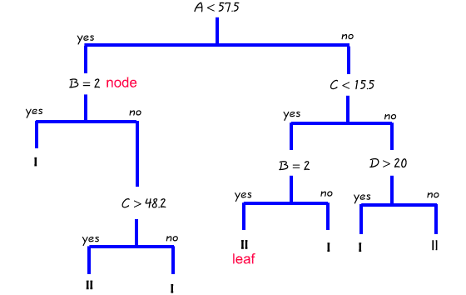

Random forest:

**Random Forest is a classifier that contains a number of decision trees on various subsets of the given dataset and takes the average to improve the predictive accuracy of that dataset.**

